Ch7 Questions, Part 2

1. Provide a summary of customer balance characteristics for customers who made purchases. Include the minimum balance, maximum balance, and average balance, as shown in Figure P7.21.

SELECT ROUND(MIN(CB),2) AS 'Minimum Balance',

ROUND(MAX(CB),2) AS 'Maximum Balance',

ROUND(AVG(CB),2) AS 'Average Balance'

FROM (

SELECT INVOICE.CUS_CODE, CUS_BALANCE AS CB

FROM INVOICE JOIN CUSTOMER ON INVOICE.CUS_CODE = CUSTOMER.CUS_CODE

GROUP BY CUS_CODE

) pita;

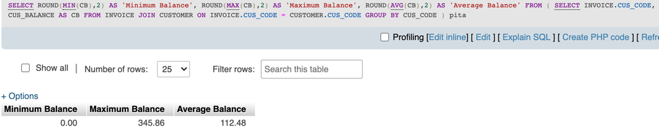

1. Create a query to find the balance characteristics for all customers, including the total of the outstanding balances. The results of this query are shown in Figure P7.22.

SELECT ROUND(SUM(CB),2) AS 'Total Balances',

ROUND(MIN(CB),2) AS 'Minimum Balance',

ROUND(MAX(CB),2) AS 'Maximum Balance',

ROUND(AVG(CB),2) AS 'Average Balance'

FROM (

SELECT CUS_BALANCE AS CB

FROM CUSTOMER

GROUP BY CUS_CODE

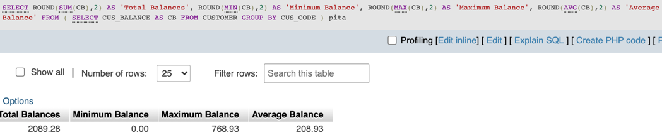 ) pita;

1. Find the listing of customers who did not make purchases during the invoicing period. Sort the results by customer code. Your output must match the output shown in Figure P7.23.

SELECT CUS_CODE, CUS_BALANCE

FROM CUSTOMER

WHERE CUS_CODE NOT IN (

SELECT CUS_CODE

FROM INVOICE

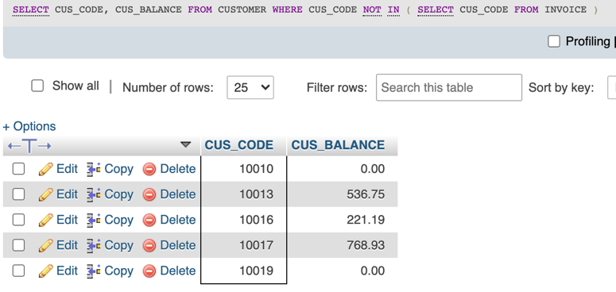 );

1. Find the customer balance summary for all customers who have not made pur- chases during the current invoicing period. The results are shown in Figure P7.24.

SELECT ROUND(SUM(CB),2) AS 'Total Balances',

ROUND(MIN(CB),2) AS 'Minimum Balance',

ROUND(MAX(CB),2) AS 'Maximum Balance',

ROUND(AVG(CB),2) AS 'Average Balance'

FROM (

SELECT CUS_BALANCE AS CB

FROM CUSTOMER

WHERE CUS_CODE NOT IN (

SELECT CUS_CODE

FROM INVOICE

)

)pita;

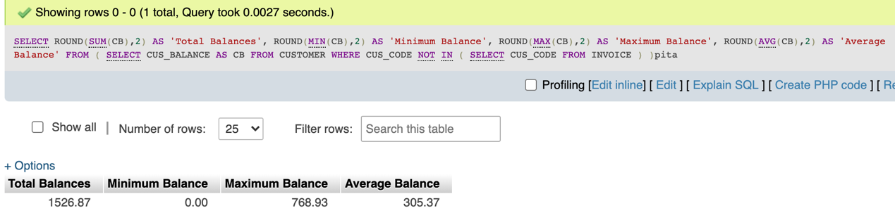

1. Create a query that summarizes the value of products currently in inventory. Note that the value of each product is a result of multiplying the units currently in inven- tory by the unit price. Sort the results in descending order by subtotal, as shown in Figure P7.25.

SELECT P_DESCRIPT, P_QOH, P_PRICE, (P_QOH * P_PRICE) AS Subtotal

FROM PRODUCT

ORDER BY P_QOH*P_PRICE DESC;

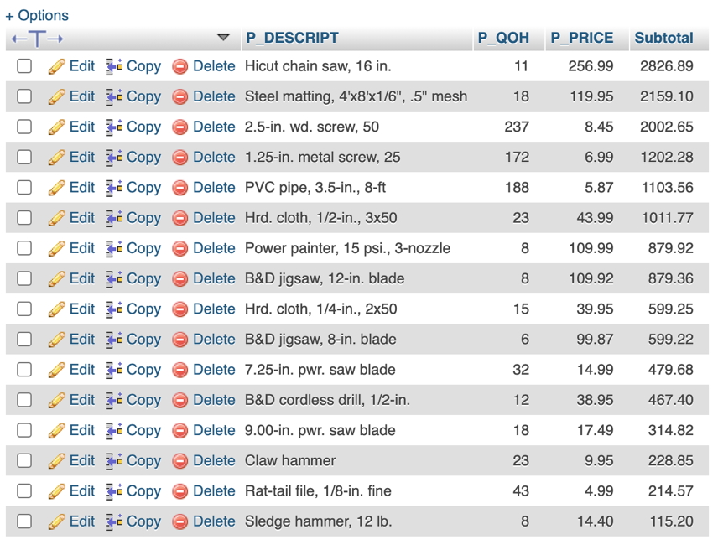

1. Find the total value of the product inventory. The results are shown in Figure P7.26.

SELECT SUM(Subtotal) AS 'Total Value of Inventory'

FROM (

SELECT (P_QOH * P_PRICE) AS Subtotal

FROM PRODUCT

)pita;

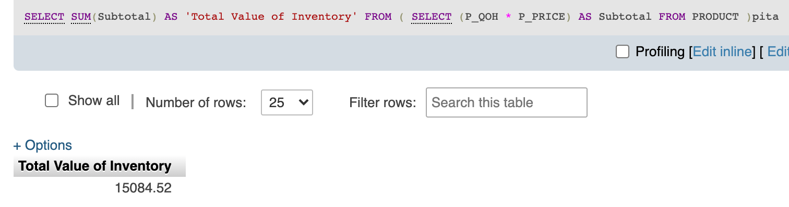

1. Write a query to display the eight departments in the LGDEPARTMENT table sorted by department name.

SELECT Dept_Name

FROM LGDEPARTMENT

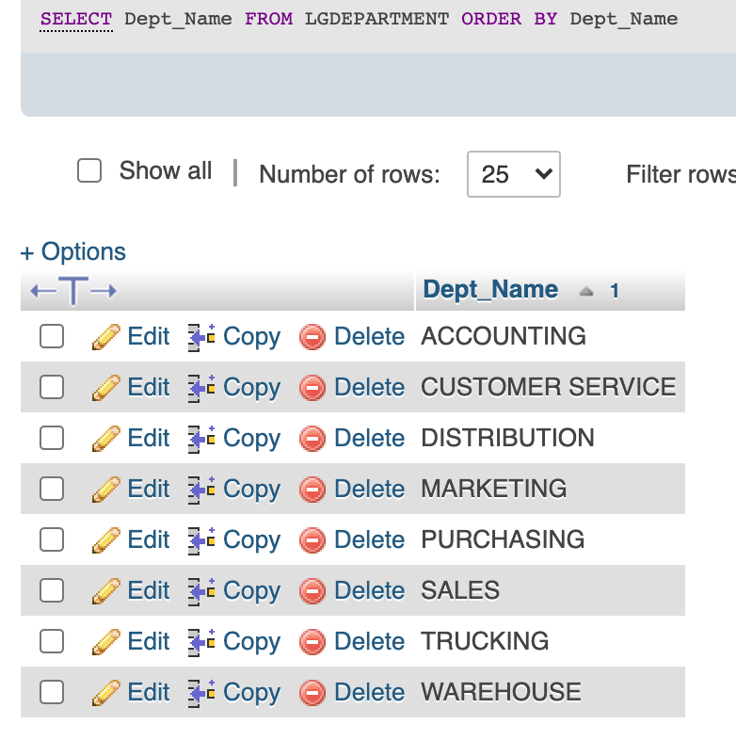ORDER BY Dept_Name;

1. Write a query to display the SKU (stock keeping unit), description, type, base, cat- egory, and price for all products that have a PROD_BASE of Water and a PROD_ CATEGORY of Sealer (Figure P7.28).

SELECT PROD_SKU, PROD_DESCRIPT, PROD_TYPE, PROD_BASE, PROD_CATEGORY, PROD_PRICE

FROM LGPRODUCT

WHERE PROD_BASE = 'Water' AND PROD_CATEGORY = 'Sealer';

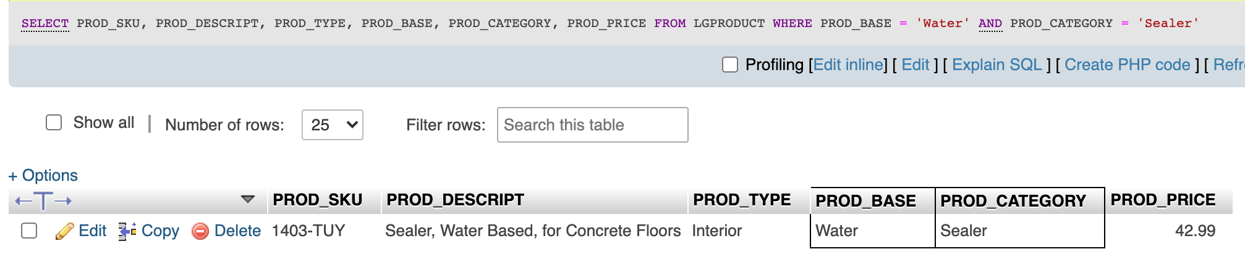

1. Write a query to display the first name, last name, and email address of employees hired from January 1, 2005, to December 31, 2014. Sort the output by last name and then by first name (Figure P7.29).

SELECT EMP_FNAME, EMP_LNAME, EMP_EMAIL

FROM LGEMPLOYEE

WHERE EMP_HIREDATE BETWEEN CAST('2005-01-01' AS DATE) AND CAST('2014-12-31' AS DATE)

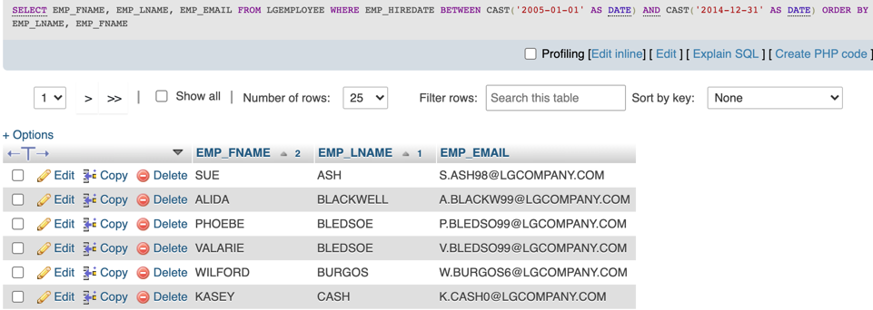ORDER BY EMP_LNAME, EMP_FNAME;

1. Write a query to display the first name, last name, phone number, title, and department number of employees who work in department 300 or have the title “CLERK I.” Sort the output by last name and then by first name (Figure P7.30).

SELECT EMP_FNAME, EMP_LNAME, EMP_PHONE, EMP_TITLE, LGDEPARTMENT.DEPT_NUM

FROM LGEMPLOYEE JOIN LGDEPARTMENT ON LGEMPLOYEE.DEPT_NUM = LGDEPARTMENT.DEPT_NUM

WHERE EMP_TITLE = 'Clerk I' OR LGEMPLOYEE.DEPT_NUM = 300

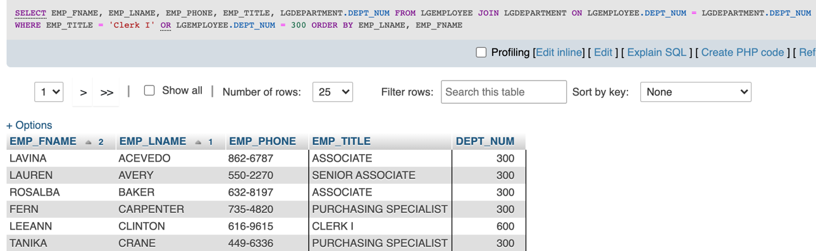ORDER BY EMP_LNAME, EMP_FNAME;

1. Write a query to display the employee number, last name, first name, salary “from” date, salary end date, and salary amount for employees 83731, 83745, and 84039. Sort the output by employee number and salary “from” date (Figure P7.31).

SELECT LGEMPLOYEE.EMP_NUM, EMP_LNAME, EMP_FNAME, SAL_FROM, SAL_END, SAL_AMOUNT

FROM LGEMPLOYEE JOIN LGSALARY_HISTORY ON LGEMPLOYEE.EMP_NUM = LGSALARY_HISTORY.EMP_NUM

WHERE LGEMPLOYEE.EMP_NUM IN (83731, 83745, 84039)

ORDER BY EMP_NUM, SAL_FROM;

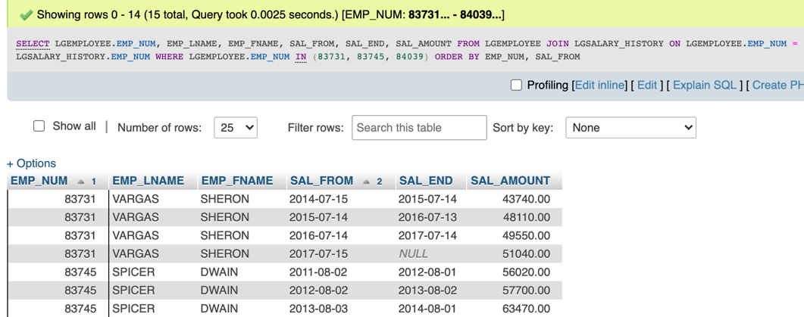

1. Write a query to display the first name, last name, street, city, state, and zip code of any customer who purchased a Foresters Best brand top coat between July 15, 2015, and July 31, 2015. If a customer purchased more than one such product, display the customer’s information only once in the output. Sort the output by state, last name, and then first name (Figure P7.32).

SELECT CUST_FNAME, CUST_LNAME, CUST_STREET, CUST_CITY, CUST_STATE, CUST_ZIP, LGINVOICE.INV_DATE

FROM LGCUSTOMER JOIN LGINVOICE ON LGCUSTOMER.CUST_CODE = LGINVOICE.CUST_CODE JOIN LGLINE ON LGINVOICE.INV_NUM = LGLINE.INV_NUM JOIN LGPRODUCT ON LGLINE.PROD_SKU = LGPRODUCT.PROD_SKU JOIN LGBRAND ON LGPRODUCT.BRAND_ID = LGBRAND.BRAND_ID

WHERE INV_DATE BETWEEN CAST('2017-07-15' AS DATE) AND CAST('2017-07-31' AS DATE) AND PROD_CATEGORY = 'TOP COAT' AND BRAND_NAME = 'FORESTERS BEST'

GROUP BY CUST_STREET

ORDER BY CUST_STATE, CUST_LNAME, CUST_FNAME;

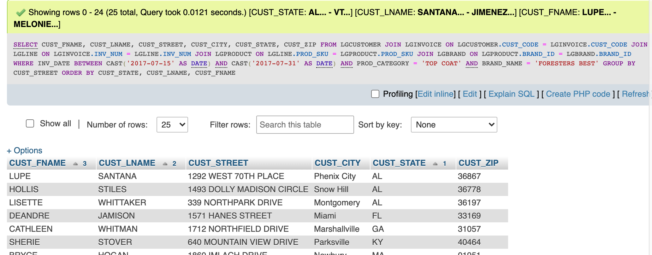

1. Write a query to display the employee number, last name, email address, title, and department name of each employee whose job title ends in the word “ASSOCIATE.” Sort the output by department name and employee title (Figure P7.33).

SELECT LGEMPLOYEE.EMP_NUM, EMP_LNAME, EMP_EMAIL, EMP_TITLE, LGDEPARTMENT.DEPT_NAME

FROM LGEMPLOYEE JOIN LGDEPARTMENT ON LGEMPLOYEE.DEPT_NUM = LGDEPARTMENT.DEPT_NUM

WHERE EMP_TITLE LIKE ('%Associate')

ORDER BY DEPT_NAME, EMP_TITLE;

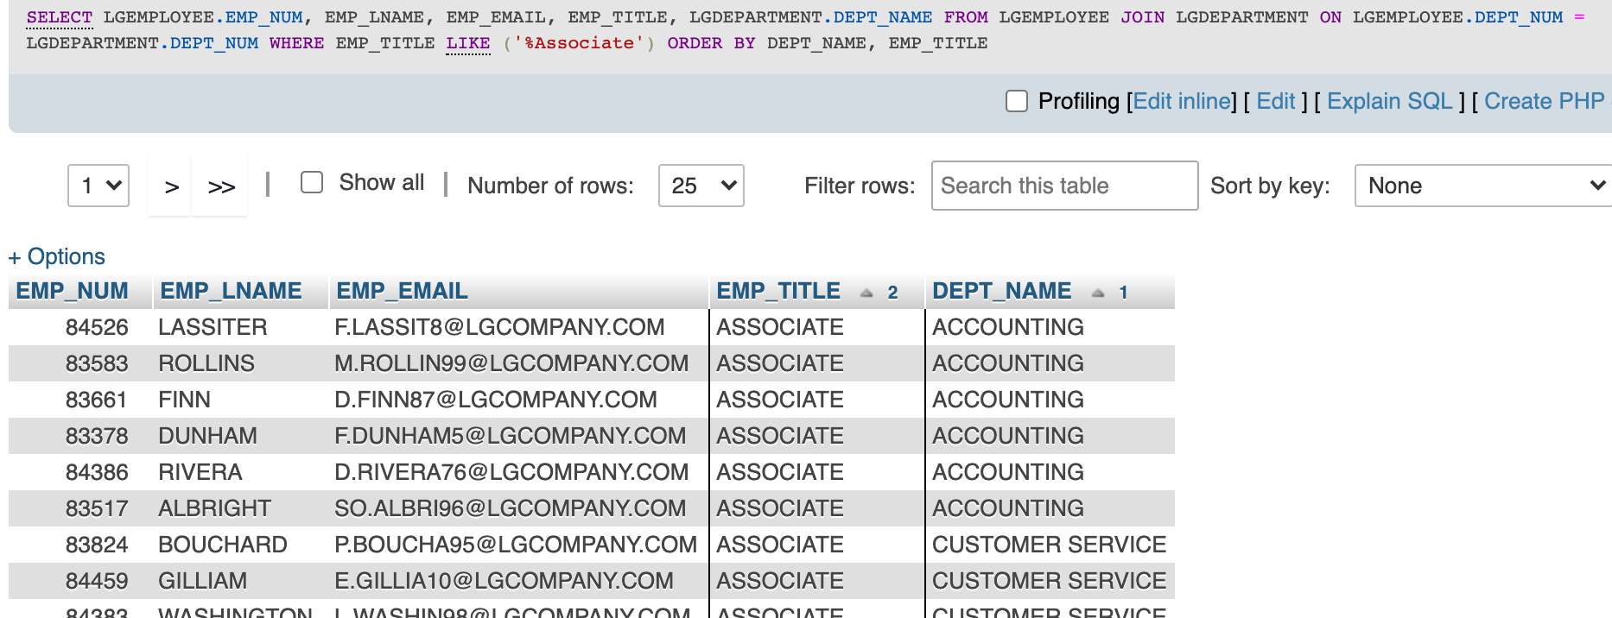

1. Write a query to display a brand name and the number of products of that brand that are in the database. Sort the output by the brand name (Figure P7.34).

SELECT BRAND_NAME, COUNT(PROD_DESCRIPT) AS NUMPRODUCTS

FROM LGBRAND JOIN LGPRODUCT ON LGBRAND.BRAND_ID = LGPRODUCT.BRAND_ID

GROUP BY BRAND_NAME

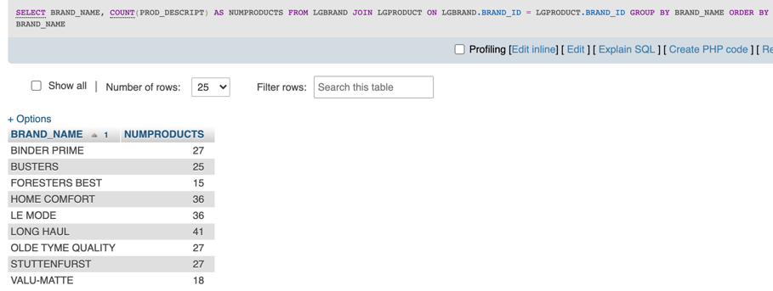ORDER BY BRAND_NAME;

1. Write a query to display the number of products in each category that have a water base, sorted by category (Figure P7.35).

SELECT PROD_CATEGORY, COUNT(PROD_DESCRIPT) AS NUMPRODUCTS

FROM LGPRODUCT

WHERE PROD_BASE = 'Water'

GROUP BY PROD_CATEGORY

ORDER BY PROD_CATEGORY;

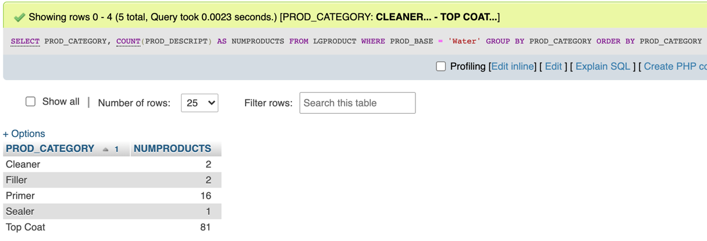

1. Write a query to display the number of products within each base and type combination, sorted by base and then by type (Figure P7.36).

SELECT PROD_BASE, PROD_TYPE, COUNT(PROD_DESCRIPT) AS NUMPRODUCTS

FROM LGPRODUCT

GROUP BY PROD_BASE, PROD_TYPE

ORDER BY PROD_BASE, PROD_TYPE;

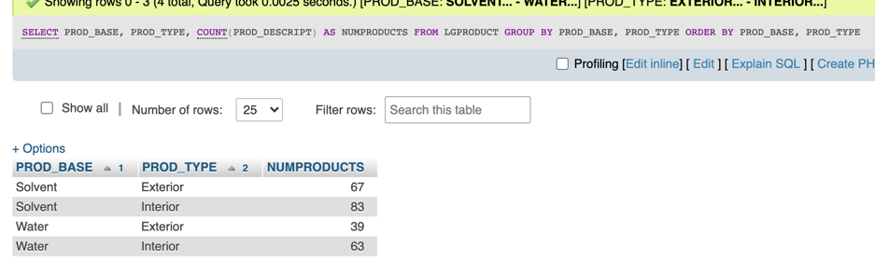

1. Write a query to display the total inventory—that is, the sum of all products on hand for each brand ID. Sort the output by brand ID in descending order (Figure P7.37).

SELECT BRAND_ID, SUM(PROD_QOH) AS TOTALINVENTORY

FROM LGPRODUCT

GROUP BY BRAND_ID

ORDER BY BRAND_ID DESC;

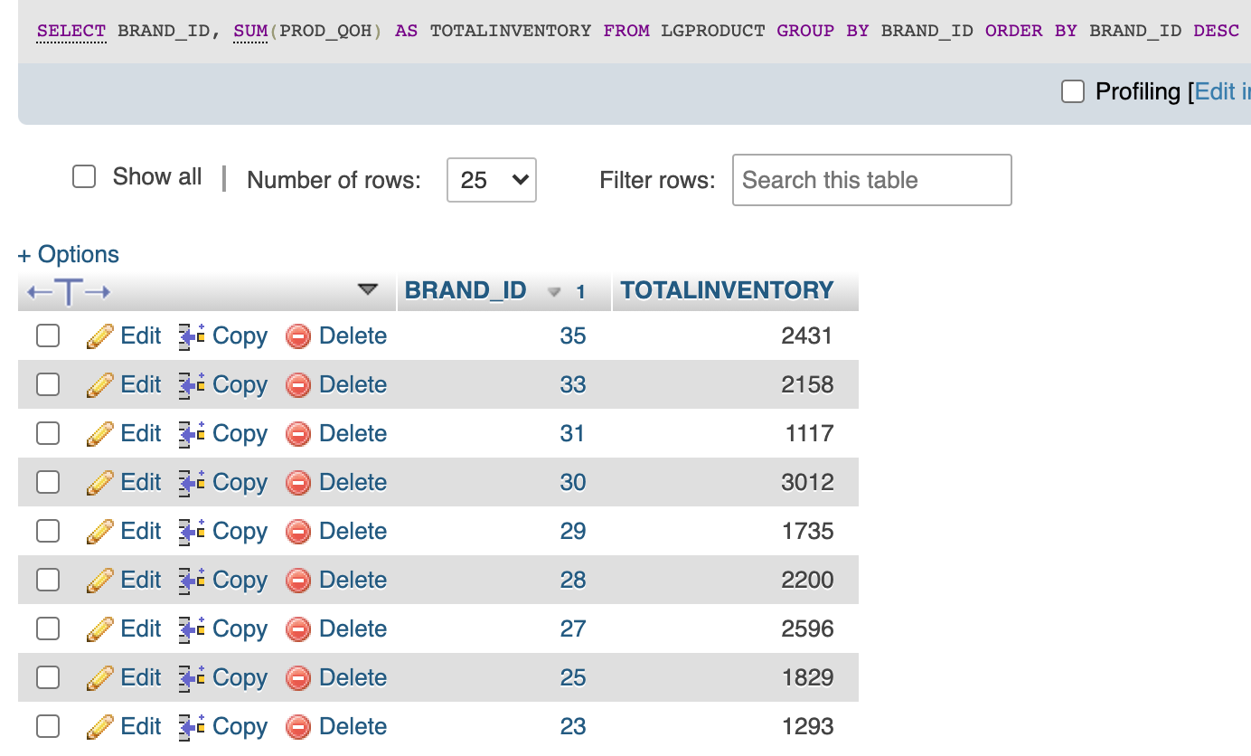

1. Write a query to display the brand ID, brand name, and average price of products of each brand. Sort the output by brand name. Results are shown with the average price rounded to two decimal places (Figure P7.38).

SELECT LGPRODUCT.BRAND_ID, BRAND_NAME, ROUND(AVG(PROD_PRICE),2) AS AVGPRICE

FROM LGPRODUCT JOIN LGBRAND ON LGPRODUCT.BRAND_ID = LGBRAND.BRAND_ID

GROUP BY BRAND_ID

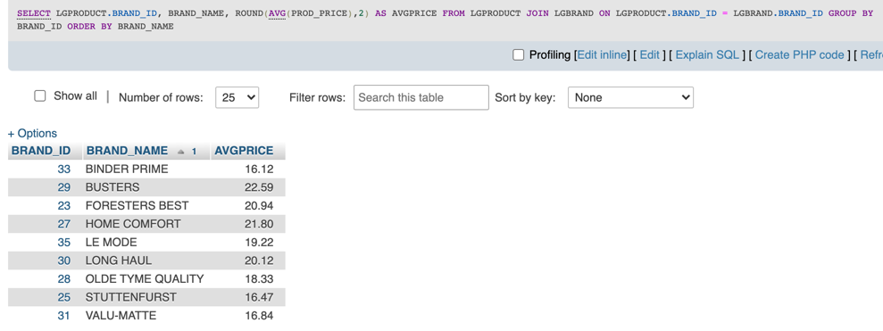ORDER BY BRAND_NAME;

1. Write a query to display the department number and most recent employee hire date for each department. Sort the output by department number (Figure P7.39)

SELECT DEPT_NUM, MAX(EMP_HIREDATE) AS MOSTRECENT

FROM LGEMPLOYEE

GROUP BY DEPT_NUM

ORDER BY DEPT_NUM;

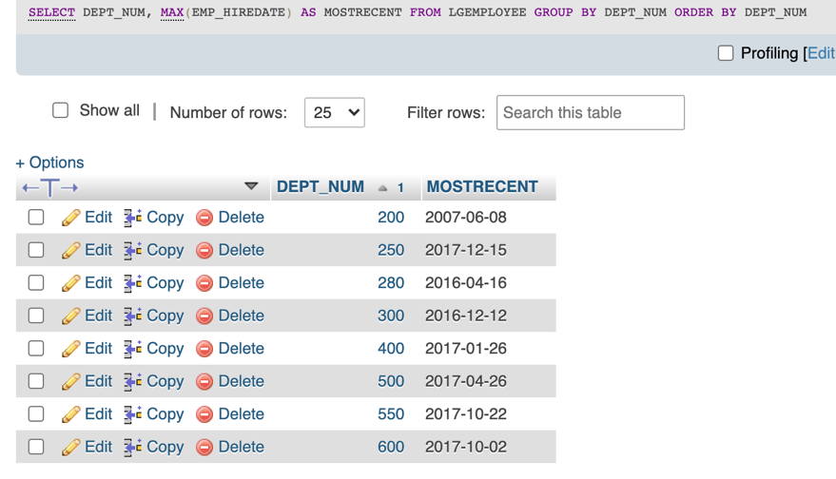

1. Write a query to display the employee number, first name, last name, and largest salary amount for each employee in department 200. Sort the output by largest sal- ary in descending order (Figure P7.40).

SELECT LGEMPLOYEE.EMP_NUM, EMP_FNAME, EMP_LNAME, MAX(LGSALARY_HISTORY.SAL_AMOUNT) AS LARGESTSALARY

FROM LGEMPLOYEE JOIN LGSALARY_HISTORY ON LGEMPLOYEE.EMP_NUM = LGSALARY_HISTORY.EMP_NUM

WHERE DEPT_NUM = 200

GROUP BY LGEMPLOYEE.EMP_NUM

ORDER BY LARGESTSALARY DESC;

